https://course.natureofproduct.com/
Conducting a special 11-workshop course via Internet "what is a product and how to make people buy it? (Customer development).

For five years I have been developing a framework that takes into account all aspects and I try to make it understandable to everyone: a startup in IT and someone who does not have an IT background at all, a farmer, a local entrepreneur and a specialist.
1
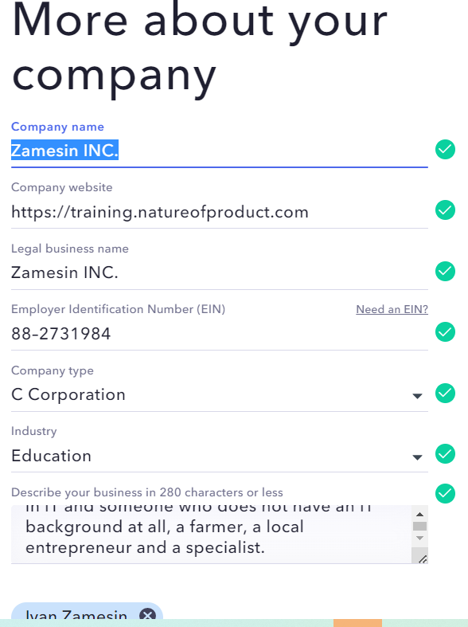
2
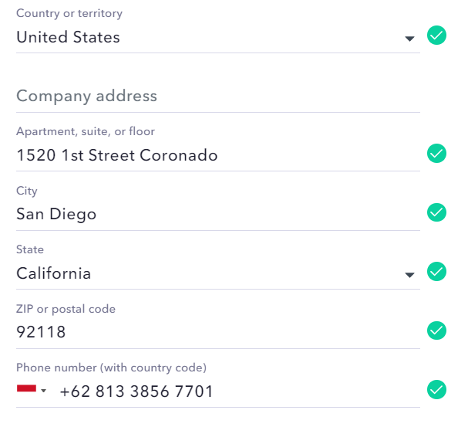
3
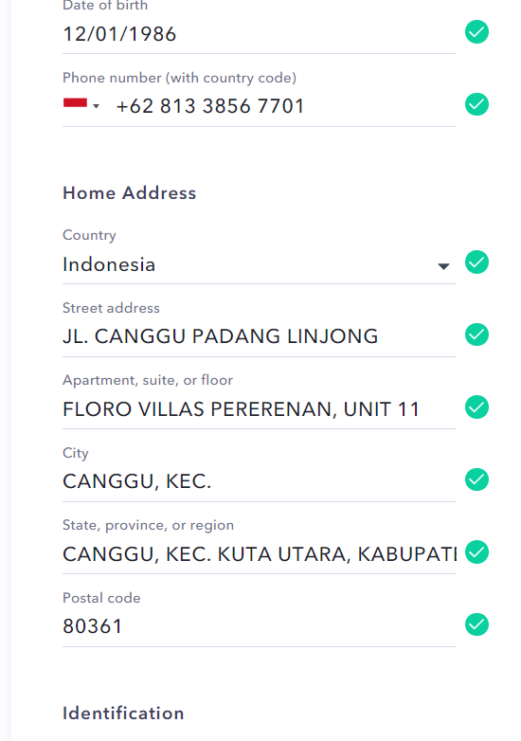
4
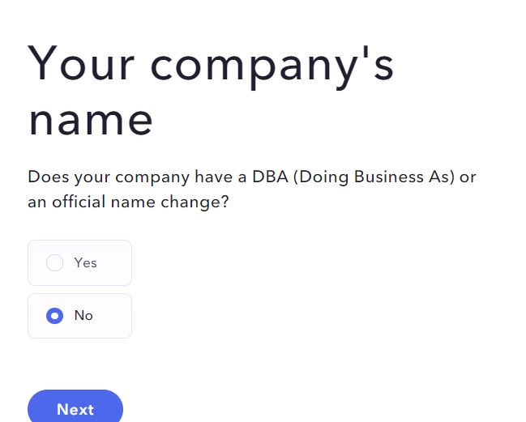
5
Using a bank account to receive payments from customers and pay for company expenses
startup in IT, someone who does not have an IT background at all, local entrepreneur, specialist on customer development
6
7

